Assignment 1: Requirements Gathering & Specification
Group - CSE-2501M
Name: Koshikov Alimzhan

Course | Software Development Case Study
Week | Week 2 - Requirements Engineering
Team Size | Maximum 2 students (same group)
Deliverables | Requirements Specification Document + Scope Diagram

Objective
Students will define the scope and requirements of their proposed software system. This forms the foundation for the entire final project, ensuring that design, development, and implementation later are aligned with a clear vision.

Connection to Final Project:
- The requirements document will serve as the baseline for system design and architecture (Assignment 3) and project planning (Assignment 2).
- All user stories, functional requirements, and non-functional requirements will directly feed into the final project.
- The clarity and completeness of this assignment will make your final project more organized and feasible.

Task Description

Part 1 - Project Planning
ML-based virtual assistant for programming
Purpose
This project is designed for helping students (freshmen) to learn programming: provide personalized assistance which analyzes students’ coding habits in real-time which includes pedagogical methodologies.
Introductory programming (CS1) remains difficult for first year students because they must simultaneously learn syntax, build semantic understanding, and develop problem decomposition skills. In large groups, beginners often cycle through compiler and logic errors via trial-and-error and receive limited individualized help, making timely formative feedback essential; yet providing it consistently at scale is constrained by instructor and TA capacity. Our proposition adresses these issues and helps students to learn easier
TELOS model:
1. Technical Feasibility
The proposed virtual mentor system is technically feasible.
The system architecture is based on modular components including real-time code analyzer, student model, and pedagogical control layer .
Modern technologies such as static code analysis, LLM-based feedback generation, real-time event processing enable implementation with acceptable latency (~741 ms in pilot results).
2. Economic Feasibility
The system is cost-effective.
Compared to hiring additional teaching assistants, the virtual mentor provides scalable support at low marginal cost.
Example:
CS50 AI assistant which costs $1.50 per student/month. Potential benefits includes 1) reduced instructor workload, 2) improved student performance, 3) scalable deployment in large courses

3. Legal Feasibility
The system complies with legal and ethical requirements.
In our system we gather and process student interaction logs which are not public
Key considerations:
- anonymization of student interaction logs
- compliance with educational data protection policies
- avoidance of plagiarism (no direct solution disclosure)
The system design explicitly avoids generating full answers, promoting academic integrity.

4. Operational Feasibility
The system is operationally feasible.
It integrates directly into the programming workflow: observes code in real time, provides feedback during problem solving
As shown in the architecture: analyzer + student model + feedback engine work continuously. This aligns with existing educational environments (e.g., IDE plugins, LMS systems).

5. Schedule Feasibility
The project is feasible within academic timelines.
Development phases:
- Prototype (3–4 months)
- Integration and testing (2–3 months)
- Pilot evaluation (1–2 months)
Given that a working prototype already exists (pilot study), full system development is realistic within a typical master’s timeline.

Part 2 - Requirements Documentation
Create a structured document that includes:
- Project Overview: Goal, main functionalities, target audience.
- Functional Requirements: Core features your system must support (as use cases or user stories).
- Non-Functional Requirements: Performance, usability, security, reliability, scalability, etc.
- Constraints & Assumptions: Tools, technologies, time, team size, or environment constraints.
Virtual Mentor System for Introductory Programming

1. Project Overview
The main idea of this project is to build a virtual mentor that can support students while they are learning programming, especially at the beginner (CS1) level. Many first-year students struggle because they have to understand syntax, logic, and problem-solving all at the same time. In large classes, it is difficult for instructors to give individual feedback, so students often rely on trial and error.
This system is designed to help solve that problem by providing feedback in real time while the student is writing code. Instead of waiting until submission, the system reacts immediately and guides the student step by step. The goal is not just to fix errors faster, but to improve understanding and reduce repeated mistakes.
In terms of functionality, the system will analyze code continuously, detect common errors, and generate feedback depending on the situation. It will also keep track of previous mistakes to adapt future feedback. Importantly, the system avoids giving direct solutions, so students are still required to think and learn.
The primary users of the system are first-year students who are learning programming. Instructors can also benefit indirectly, as the system reduces repetitive questions and provides additional support during practical sessions.

2. Functional Requirements
The system should support the full cycle of student interaction during coding.
First, it needs to monitor code changes in real time. Every time a student edits their code, the system should analyze it without requiring manual submission. This allows the mentor to detect issues early.
Second, the system must be able to identify different types of errors. This includes basic syntax problems, but also common beginner mistakes and simple logical issues. The goal is not full program verification, but practical guidance for learning.
Another important requirement is maintaining a simple student model. The system should keep track of how often certain errors occur and what kind of feedback has already been given. This allows it to adapt over time instead of treating every interaction independently.
Based on this information, the system should generate feedback. The feedback is not always the same — sometimes it may highlight a piece of code, sometimes provide a hint, and sometimes ask a guiding question. In some cases, it may intentionally give no feedback if the student is progressing well. This decision is controlled by a pedagogical policy.
A key requirement is that the system should not provide full solutions. Its role is to guide, not replace learning. This helps prevent over-reliance and supports independent thinking.
The system should also respond quickly. Since the interaction happens during coding, delays would reduce its usefulness. Ideally, feedback should appear almost instantly.
Finally, all interactions should be logged. These logs can later be used to improve the system and train models that decide what type of feedback works best.

3. Non-Functional Requirements

Besides functionality, the system must meet several quality requirements.
Performance is critical. Since feedback is provided during coding, the response time should be very low, ideally under one second. The system should also handle multiple students working at the same time without noticeable delays.
Usability is also important. The system should be integrated into a web-based IDE or similar environment, so students do not need to switch tools. Feedback should be easy to understand and not overwhelming.
Reliability means the system should work consistently during coding sessions. It should not crash or stop responding, especially during important tasks.
Scalability is another consideration. The system should be able to support large classes, potentially with hundreds of students using it simultaneously.
Security and privacy must be respected. Student data, especially interaction logs, should be stored safely and anonymized where necessary.
Maintainability is also relevant from a development perspective. The system should have a modular structure so that components like the analyzer or feedback logic can be updated independently.
Finally, there are ethical considerations. The system should not encourage cheating or dependency. It must be designed to support learning rather than replace effort.

4. Constraints & Assumptions

4.1 Constraints
There are several constraints that affect the project.
From a technical point of view, the system needs to operate in real time, which limits the use of heavy or slow models during execution. Any advanced processing should either be optimized or moved outside the critical path.
Time is also a constraint, since the project is part of a master’s program. Development, testing, and evaluation all need to fit within academic deadlines.
Resources are limited as well. The system is being developed by a small team (or even a single developer), and infrastructure costs must be kept reasonable.
There are also some assumptions. It is assumed that students will use a web-based environment for coding, and that tasks will be at an introductory level. It is also assumed that internet access is available, and that interaction logs can be collected for improving the system over time.

Part 3 - Initial System Scope Diagram
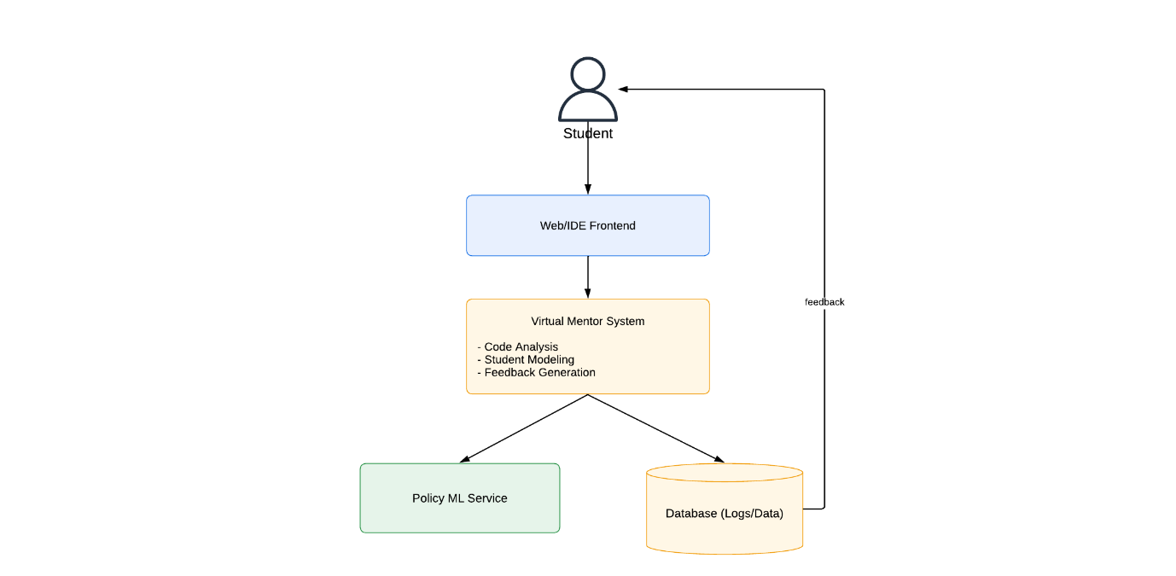
Figure 1. High-Level System Scope Diagram of the Virtual Mentor System

Deliverables
Submit the following two items:
• Requirements Specification Document - PDF or Word (.docx), structured according to Parts 1 and 2 above (including the AI Tools Usage Log in Section 2.5)
• Initial System Scope Diagram - can be embedded in the document or submitted as a separate image/PDF

Evaluation Criteria
Criterion  max points | Excellent  90–100% | Good  70–89% | Satisfactory  50–69% | Fail  0–49%
Part 1 - Project Planning  30 points | 27–30 pts  The purpose, target users, feasibility study, and value proposition are clear and convincing. The reader immediately understands what the system does and why it is important. | 21–26 pts  The idea is clear, but the value proposition, feasibility study, or target audience lacks some detail. | 15–20 pts  Basic idea is present but vague - missing context or audience definition. | 0–14 pts  No clear idea or description is too generic to evaluate.
Part 2 - Requirements Documentation  30 points | 27–30 pts  All sections are complete: at least 5 well-formed user stories, 4 measurable NFR categories, and clearly documented constraints and assumptions. | 21–26 pts  Most sections are well-structured, but some requirements lack depth, measurability, or completeness. | 15–20 pts  Basic requirements present but missing structure, important categories, or measurable criteria. | 0–14 pts  Requirements are incomplete, unclear, or inconsistent with the stated project.
Part 3 - Scope Diagram  30 points | 27–30 pts  Clearly shows main modules, key actors, and data/control flow. Clean, readable, and fully consistent with the written requirements. | 21–26 pts  Shows modules and actors, but the flow between components is unclear or partially missing. | 15–20 pts  Diagram present but very basic - missing actors, major components, or flow. | 0–14 pts  No diagram, or unreadable/inconsistent with the document.
AI Tools Documentation  10 points | Graded as complete/incomplete - not on a grade scale.  10 pts - Every AI tool use is logged with: tool name, specific purpose, and honest reflection on what was kept, changed, or rejected.  0 pts - No log, vague log, or AI was clearly used but not documented.

P.S Sorry for late submit, I was doing several tasks simultaneously at work, so I simply forget to submit this assignment in time :)

